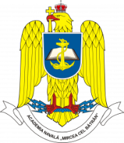 |  | “CADET-NAV – International Students’ Scientific Conference”  ”Mircea cel Batran” Naval Academy,  CONSTANTA/ROMANIA  11th – 13th of May 2024  Application form  (for military cadets only) | 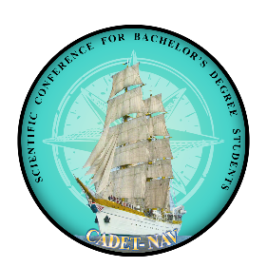
COUNTRY
UNIVERSITY
POC:
Email:
Phone number
Attendees:
1 | Military / Civilian |  | Title |  | Sex |  |  | Date of birth  DD/MM/YY |  | ID/Passport  number
 | M C |  |  |  | F M
 | Name (first / last)
2 | Military / Civilian |  | Title |  | Sex |  |  | Date of birth  DD/MM/YY |  | ID/Passport  number
 | M C |  |  |  | F M
 | Name (first / last)
3 | Military / Civilian |  | Title |  | Sex |  |  | Date of birth  DD/MM/YY |  | ID/Passport  number
 | M C |  |  |  | F M
 | Name (first / last)
ITINERARY
Arrival |  | Plane Bus Personal Car Other
Date / Hour
Airport
Departure |  | Plane Bus Personal Car Other
Date / Hour
Airport
ACCOMMODATION FORM – to be booked individually or by the organizer
11/04/2024 to 12/04/2024 |  |  |  | YES NO |  |  | Hostel of MBNA or  optional hotel
12/04/2024 to 13/04/2024 |  |  |  | YES NO
13/04/2024 to 14/04/2024 |  |  |  | YES NO
SPECIAL REQUESTS & QUESTIONS

Remarks:
- The flight details will be extended once available.

Upon completion submit the final form to MBNA PoC: Capt. Clinci Catalin, cadetnav@anmb.ro

